Name of the Student: G. Manasa | Academic Year: 2025-26
Student Registration Number: 241U1R3007 | Year & Term: II & III
Study Level: UG | Class & Section: CSE-DS-2A
Name of the Course: Database Management system | Name of the Instructor: Mr. Pranay Vemula, Assistant Professor, CSE.
Name of the Assessment: Group Assignment | Date of Submission: 24-02-2026

Group Assignment



My Learnings:
In the Database Management System Part – 1 course, I learned the fundamental concepts of databases and how they are used to store and manage data efficiently. I understood the difference between data and information and why databases are important in real-world applications like banking, hospitals, colleges, and companies.
I learned about the structure of relational databases, where data is stored in tables with rows and columns. I understood important concepts such as primary key, foreign key, candidate key, and super key. I also learned how relationships are formed between tables like one-to-one, one-to-many, and many-to-many relationships.
The course helped me understand ER diagrams and how to design a database schema properly. I learned about normalization and how it reduces data redundancy and improves data consistency. I also gained basic knowledge of SQL queries to insert, update, delete, and retrieve data from tables.

LG -08
- Explain structure of relational database.
Structure of Relational Database
A Relational Database is a type of database that stores data in the form of tables (relations). It is based on the relational model
Relation (Table)
- Data is stored in tables.
- Each table represents one entity.
- Example: STUDENT, COURSE, EMPLOYEE.
Example:
STUDENT (SID, Name, Dept, Age)
SID | Name | Dept | Age
S1 | Riya | CSE | 20
S2 | Arun | ECE | 21

Attributes (Columns)
- Attributes are the properties of an entity.
- Each column has a name and data type.
- Example: SID (Integer), Name (Varchar), Age (Integer)
Each attribute has a domain, which means the set of valid values.
Example:
- Age → 0–100
- Dept → {CSE, ECE, MECH}
Tuples (Rows)
- Each row in a table is called a tuple.
- A tuple represents one complete record.
- Example: (S1, Riya, CSE, 20)
Relation Schema
- The structure of a table is called relation schema.
Relation_Name (Attribute1, Attribute2, Attribute3, …)

Example:
STUDENT (SID, Name, Dept, Age)
The actual data stored is called the relation instance.
Keys
Keys are used to uniquely identify records and maintain relationships.
- Primary Key → Uniquely identifies each record
- Foreign Key → Connects two tables
- Candidate Key
- Super Key
Example:
- SID → Primary Key in STUDENT
- DeptID → Foreign Key in STUDENT referencing DEPARTMENT
Relationships Between Tables
Tables are connected using foreign keys.
Example:
DEPARTMENT(DeptID, DeptName)
STUDENT(SID, Name, DeptID)
Here:
- DeptID in STUDENT refers to DeptID in DEPARTMENT
- This creates a relationship
Types of relationships:
- One-to-One
- One-to-Many
- Many-to-Many

- Define keys: super key, candidate key, primary key and foreign key.
Keys in Relational Database
Keys are attributes (or set of attributes) used to uniquely identify records in a table and to establish relationships between tables.
1.Super Key
A Super Key is a set of one or more attributes that uniquely identifies each tuple (row) in a relation.
It may contain extra attributes.
Example:
STUDENT (SID, Name, Email, Dept)
If SID is unique, then possible super keys are:
- {SID}
- {SID, Name}
- {SID, Email}
- {SID, Name, Dept}
All these uniquely identify records, so they are super keys.
2.Candidate Key
A Candidate Key is a minimal super key.
It contains no unnecessary attribute.
If any attribute is removed, it will no longer uniquely identify the record.
Example:
If both SID and Email are unique:
Candidate Keys:
- {SID}
- {Email}
But {SID, Name} is NOT a candidate key because Name is unnecessary.
3.Primary Key
A Primary Key is one candidate key chosen to uniquely identify records in a table.
Only one primary key per table
Cannot be NULL
Must be unique
Example:
STUDENT (SID, Name, Email, Dept)
If SID and Email are candidate keys, we choose:
Primary Key = SID
4.Foreign Key
A Foreign Key is an attribute in one table that refers to the primary key of another table.
Used to maintain relationships between tables
Enforces referential integrity
Example:
DEPARTMENT (DeptID, DeptName)
STUDENT (SID, Name, DeptID)
Here:
- DeptID in STUDENT is a Foreign Key
- It refers to DeptID in DEPARTMENT

- Decompose relation into 5NF.
What is 5NF?
Fifth Normal Form (5NF), also called Project-Join Normal Form (PJNF), removes redundancy caused by join dependency.
A relation is in 5NF if:
- It is already in 4NF
- It has no non-trivial join dependencies
- It cannot be further decomposed without loss of information
Example of Decomposition into 5NF
Consider relation:
R(Supplier, Part, Project)
Assume:
- Supplier supplies Part
- Supplier works on Project
- Part is used in Project
This creates redundancy.

Step 1: Original Table
Supplier | Part | Project
S1 | P1 | J1
S1 | P2 | J1
S2 | P1 | J1

This relation may contain join dependency.
Step 2: Decompose into Three Relations
We decompose R into:
SP(Supplier, Part)
SJ(Supplier, Project)
PJ(Part, Project)
Step 3: Result
Now:
SP Table:
Supplier | Part
S1 | P1
S1 | P2
S2 | P1

SJ Table:
Supplier | Project
S1 | J1
S2 | J1

PJ Table:
Part | Project
P1 | J1
P2 | J1

- Identify keys from given relation schema.
To identify keys in a relation schema, we must find:
- Super Keys
- Candidate Keys
- Primary Key
- Foreign Key
Step-by-Step Method to Identify Keys
Step 1: Check Functional Dependencies (FDs)
Find which attribute(s) uniquely determine other attributes.
Example:
If
EID → Name, Dept, Salary
then EID uniquely identifies the record.
Step 2: Find Super Keys
A super key is any set of attributes that uniquely identifies a tuple.
If EID is unique, then:
- {EID}
- {EID, Name}
- {EID, Dept}
- {EID, Salary}
All are super keys.
Step 3: Find Candidate Keys
A candidate key is a minimal super key.
From above:
- {EID} is minimal → Candidate Key
- {EID, Name} is not minimal → Not candidate key
Step 4: Choose Primary Key
One candidate key is selected as Primary Key.
Usually:
- Choose simple attribute
- No NULL values
Primary Key = EID
Step 5: Identify Foreign Keys
If an attribute refers to primary key of another table, it is a foreign key.
Example:
EMPLOYEE(EID, Name, DeptID)
DEPARTMENT(DeptID, DeptName)
DeptID in EMPLOYEE is Foreign Key.
Example
Relation:
STUDENT(SID, Name, Email, Phone)
Keys:
Super Keys: {SID}, {Email}, {SID, Name}, {Email, Phone}
Candidate Keys: {SID}, {Email}
Primary Key: SID (chosen)
Foreign Key: None (if single table)

- Draw relational schema diagram for a course registration system.
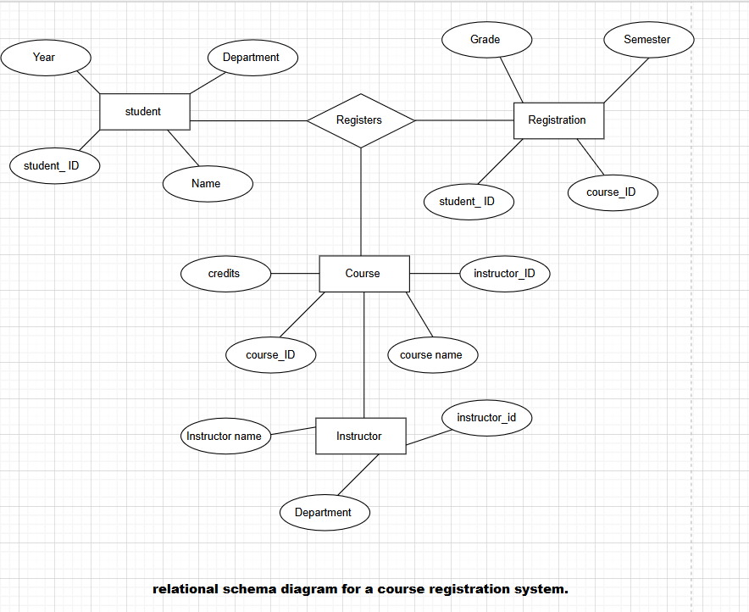

Relational Schema
STUDENT: STUDENT (SID, Name, Dept, Year)
- Primary Key: SID
COURSE: COURSE (CID, CName, Credits, IID)
- Primary Key: CID
- Foreign Key: IID → INSTRUCTOR(IID)
INSTRUCTOR: INSTRUCTOR (IID, IName, Dept)
- Primary Key: IID
REGISTRATION: REGISTRATION (SID, CID, Semester, Grade)
- Primary Key: (SID, CID, Semester) → Composite Key
- Foreign Keys:
  - SID → STUDENT(SID)
  - CID → COURSE(CID)

